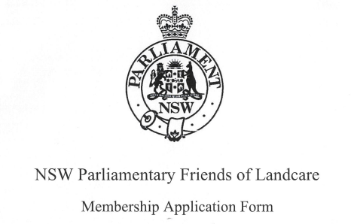

Name:____________________________________________________________________

Address:__________________________________________________________________

Postcode:________________________ Contact Number:__________________________

Email:____________________________________________________________________

Annual Membership Fee of $25 is payable
Direct Deposit Payment Details:
Bank: St. George Account
BSB: 112-879
Account Number: 459 110 705
(Please include your name when you deposit your annual membership fee for administration)

Complete and return this form via email to the office of Roy Butler MP (Parliamentary Friends of Landcare Treasurer) to barwon@parliament.nsw.gov.au

